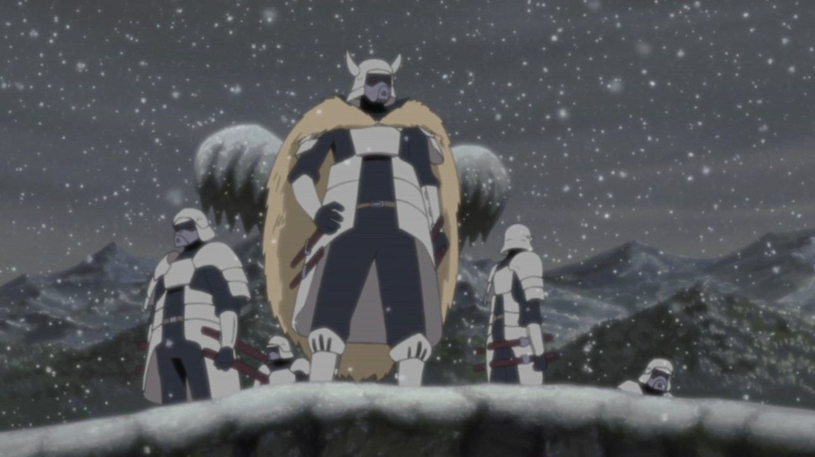

**The Samurai**

The Samurai (侍) are a military power similar but separate from the shinobi and currently are under and reside with the Don’Yoku. They are known for their extremely hard training course to become a Samurai. Samurai are feared for their extensive prowess with weaponry and their undying commitment to their way.

History

**Preface**

The Samurai date far back into history, the first traces coming from a land off the coast of The Isle called Mt. Kongo. This is where the Samurai trained and built their forces. The Samurai singlehandedly drove back the scourge of the beast on their own land, a feat that couldn’t be accomplished by those on the Isle even with their grasp of chakra. The Shogun, leader of the Samurai, banished those from The Isle to enter Mt. Kongo and vice versa once Asahi had began to seal fractions of the All-Beast into humans, this was considered an act of pure evil. From that moment Mt. Kongo waged war with The Isle, attempting to purge them from the face of the earth. Even with their advanced ninjutsu and Jinchuriki The Isle had a difficult fight against the Samurai. The Samurai being the only ones who had been able to stand against the clans of The Isle even while united were quite formidable. The Don’Yoku being challenged in their quest to conquer The Isle by the Senju, hired and the help of the Samurai. The Samurai’s home and economy being nearly destroyed left the new Shogun with no choice, and with this the end of the Senju Clans reign had come.

**Current**

The Samurai currently work from Don’Yoku city, being their call-to-arms militia as well as carrying out tasks for the land. They protect the general populace around the land from raids while collecting things such as food and water, although they gain much support from Don’Yoku they establish a good relation with the smaller villages of The Isles with this trade. They often take less than a fraction of the villages supplies, and grant them their own protection.

Description

The Samurai come in various shapes, sizes, and looks, being from Mt. Kongo and often clanless members of The Isle. When performing their daily duty, they are expected to wear their helm at all times so that one Samurai cannot be difficilitated from another. This is so that one’s task reflects on all, all the bad that one does will reflect on others as well as the good. This is put in place to make Samurai think twice about actions that would be considered unseemly. Samurai after going through the training and schooling are expected to uphold their General Orders in public at all times.

Player Guide

*Samurai do not have a defined way, they come in various styles. Although Samurai are expected to act noble and bravely. They have a good aura around themselves often depicted as heroes amongst non-clans and outer villages, often by posters and preaching of the Don’Yoku. The Shogun is considered the General of Armed Militia and holds a tittle directly below the Don’Yoku themselves, basically being the leader of Don’Yoku City when it comes to matters of conduct, policies, and warfare.*

- Samurai are strong willed due to the rigorous process it takes to become a Samurai

-Samurai cannot use any of the shinobi General Skills, although they are still able to traverse water and climb flat surfaces using chakra.

-Samurai are considered adults once they become Samurai and are treated as such by in their community at all times.

-Samurai are highly revered in Don’Yoku City, being the most loved figures of the town by it’s people.